

**AMERICAN INTERNATIONAL UNIVERSITY–BANGLADESH (AIUB)**

**FACULTY OF SCIENCE & INFORMATION TECHNOLOGY**

**INTERNSHIP AFFILIATIONREPORT ON**

***Internship at NCC Bank Limited***

An Internship Report Presented to the

OFFICE OF PLACEMENT and

DEPARTMENT OF COMPUTER SCIENCE

In Partial Fulfillment of the Requirements for the Degree

***Bachelor of Science in Computer Science and Engineering***

**Supervised By**

**MD. Sadrul Amin**

**System Analyst**

**Software Development Department (SDD)**

**American International University – Bangladesh**

**Submitted By**

**Sazen, MD. Hasibur Rahman**

**19-40905-2**

**Bachelor of Science in Computer Science & Engineering**

Fall 2022-2023

Date of Submission: **December 15, 2022**

# LETTER OF SUBMITTAL

15 December,20222

Md. Sadrul Amin

System Analyst

Software Development Department (SDD)

American International University of Bangladesh

Subject: Intern at NCC Bank Ltd

Dear Sir,

With due respect, I am a student of your renowned institution submitting my internship report on the IT Department at “NCC Bank Limited” under the supervisor of Md. Mosabber Hossain In-charge of the Information Technology Service Management(ITSM). I was exposed to the IT sector of the bank and was able to learn a great deal about how the bank’s IT services work due to this internship opportunity at NCC Bank Limited. I give IT support to the head office as well as the branches remotely. I also set up computer labs for their training institute. Even though there were a few flaws, I believe that the experience I've had has greatly served its intended purpose. I express my sincere gratitude for the opportunity to report on this subject. I correctly comprehended and carried out my obligations, and finished my paper within the allotted time frame.

I am happy and honored to be a part of this internship program and I’d like to express my gratitude to you and my honorable office supervisors for providing me with the opportunity to take part in this internship.

Your Sincerely,



Sazen, MD. Hasibur Rahman

19-40905-2

Bachelor of Science in Computer Science and Engineering

15 December 2022

**LETTER OF ENDORSEMENT**

The Internship Affiliation Report entitled “*Internship at NCC Bank Limited*”, has been submitted to the Office of Placement and Department of Computer Science in partial fulfillment of the requirements for the degree of **Bachelor of Science in Computer Science & Engineering** by **Sazen, MD. Hasibur Rahman, 19-40905-2**. This report is presented to the Internship Defense Committee for evaluation and has been accepted.

(*Any opinions, suggestions made in this report are entirely that of the author of the report. The University does not condone nor reject any of these opinions or suggestions.*)

|  |  |  |
| --- | --- | --- |
|  |  |  |
| MD. SADRUL AMIN  *Internship Supervisor* (academic)  System Analyst  Software Development Department (SDD) *American International University- Bangladesh* |  | Md. Mosabber Hossain  *Internship Supervisor* (industry)  Vice President, Head of ITSM  NCC Bank Limited |
|  |  |  |
| MD. AL-AMIN  Internship Supervisor (External)  Lecture  Department of Computer Science  *Faculty of Science & Technology* |  | Prof. Dr. Dip Nandi  Professor & Director  Department of Computer Science  *Faculty of Science & Information Technology* |

**ACKNOWLEDGEMENT**

First of all, I would like to thank almighty Allah, for his grace in accomplishing my internship report timely.

I would like to express my gratitude to the **Faculty of Science & Technology** to keep internship credit in the curriculum of the graduation program and give me a scope of tasting the flavor of industry oriented tasks and the field of work with my interest. I am also grateful to the **Faculty of Science & Technology & Office of Placement & Alumni**, AIUB to arrange an opportunity for choosing an own interested organization and complete internship there.

I am also thankful to my organization supervisor **Md. Mosabber Hossain**, Vice President & Head of ITSM department, IT division, *NCC Bank Limited* from the core of my heart for his kind support, guidance, constructive, supervision, instructions and advice and for motivating me to do my internship smoothly at *NCC Bank*.

I feel proud and gratified that I was always held the under supervision of the Information Technology Service Management team and got advices directly from **Muhammad Alihyder Bhuiyan**, Assistant Vice President, Head of Infrastructure team, *NCC Bank Limited*. Here, with daily reporting along with mental and professional support enhances my experience in the internship life.

I am also indebted to the employees of ITSM team specially **Ziaus Samad**, System Administrator, *NCC Bank Limited* who gave me immense support while working on project and also in technical issues. Moreover, to prepare this report and other documentation regarding Internship Report and else I would show appreciation to all the members of Information Technology Service Management(ITSM) team, who always advised me and helped me through hands and pens.

# TABLE OF CONTENTS

|  |  |
| --- | --- |
| **TOPICS** | ***Page no*.** |
| 1. **Title Page** | 1 |
| 1. **Letter of Submittal** | 2 |
| 1. **Letter of Endorsement** | 3 |
| 1. **Acknowledgement** | 4 |
| 1. **Table of Content** | 5 |
| 1. **List of Tables &Figures** | 6 |
| 1. **Introduction** | 7 |
| * 1. Rationale | 7 |
| * 1. Background | 8 |
| * 1. Objectives | 11 |
| 1. **Activities** | 12 |
| * 1. Work Load | 12 |
| * 1. Organization Wide | 13 |
| * 1. Other Relevant Activities | 14 |
| 1. **Constraints/Challenges** | 15 |
| * 1. Identified/Observed in the Organization | 16 |
| * 1. Academic Preparation | 17 |
| * 1. Personal/Professional Skills | 18 |
| 1. **Acquired Knowledge** | 19 |
| * 1. Consequences to Organization | 19 |
| * 1. Implications to University’s Internship Program | 20 |
| * 1. Effects on Personal/Professional Skills | 20 |
| 1. **Concluding Statements** | 21 |
| * 1. Summary | 21 |
| * 1. Recommendations/Suggestions for future strategic actions | 21 |
| * + 1. Organization | 21 |
| * + 1. University | 22 |
| * + 1. Personal/Professional | 22 |
| 1. **Recommendation Letters** | 23 |
| 1. **References** | 24 |
| 1. **Appendices** | 25 |

**LIST OF TABLES & FIGURES**

|  |  |
| --- | --- |
| **TITLES** | ***Page no*.** |
| **1.1 figure: student-teacher ratio** | 3 |
|  |  |
|  |  |
|  |  |
|  |  |
|  |  |
|  |  |
|  |  |
|  |  |
|  |  |
|  |  |
|  |  |
|  |  |
|  |  |
|  |  |
|  |  |
|  |  |
|  |  |
|  |  |
|  |  |
|  |  |
|  |  |
|  |  |
|  |  |
|  |  |
|  |  |
|  |  |
|  |  |
|  |  |
|  |  |

1. **INTRODUCTION**

**Content of this chapter must not exceed more than 2 pages.**

* 1. Rationale: The internship program has been really helpful in improving both my profession and my communication skills. in order to further my internship program. I have the opportunity to become familiar with the banking IT environment because I work in the NCC Bank Limited head office. I had the chance to gain skills working in various IT division departments. With the help of group discussions and group activity sessions, I was able to identify problematic situations. The training has helped me better understand the differences between academic education and the demands of an IT office culture. It includes all of the necessary information for the three-credit internship course. I had access to all of my vast expertise and experience.
  2. Background: A private commercial bank in Bangladesh is known as NCC Bank Limited or National Credit and Commerce Bank Limited. The bank's current managing director and CEO is Mohammad Mamdudur Rashid. In 1985, NCC Bank was established as an investment firm under the moniker NCL (National Credit Limited). It began with a paid-up capital of Tk. 39 crore and was given permission by the central bank to become a scheduled commercial bank in 1993. Through its 156 branches, 133 ATMs, and 15 extension counters located across the country from the Far West to the Far East, NCC now offers banking facilities and services to rural and urban areas of the country.
  3. Objectives: Traditional classroom environments are insufficient for teaching professional skills. I was first really nervous about working in the real world. I was able to gain a practical understanding of how to operate in real life, in industry, or in an organization by visiting the headquarters because, up until that point, I had only a theoretical understanding of those concepts. This experience gave me more confidence and allowed me to eventually develop my ability to work with people, officers, and management. The ability to communicate with others is another essential talent I have acquired. My improved verbal accuracy My level of activity and confidence overall increased as a result of the internship.

1. **ACTIVITIES**
   1. Work-Related: As an intern, I have always been present so that I may watch them at work and get practical knowledge. They gave me a fantastic opportunity and platform to gain the knowledge I needed, and I worked hard to take use of that opportunity. Due to time and resource constraints, though, as an intern there, I was practically unable to work on it entirely. But I've learned how to remotely support other branches and our headquarters office's technical staff in real-world situations. I also spent a lot of time troubleshooting a new project for the bank that is based on "The Manage Engine" software. Create computer labs for their training facility as well. Furthermore, I put up a lab for their training facility. Additionally, I created a list of every computer in the NCC bank's network, including information about each computer's IP address, configuration, and security patch upgrades. And because I have to enter my data into Microsoft Excel every day and submit my report, I have become an expert user of the MS program.
   2. Organization-wide: I'm engaged by NCC Bank Limited's Information Technology Service Management (ITSM) department, which is a part of the IT division. One of the bank's important and busiest departments is this one. The network crew and system team are constantly busy. Either physically or virtually, they are working. Due to the heavy workload, office hours end at 5 pm but employees must continue working until 7 or 8 pm every day. Every night, someone must work night duty at the data center since they maintain the bank's servers. They offer assistance with technology. Introduce new tools and software for the bank's operations. Therefore, this division is a crucial division of the bank.
   3. Other relevant activities: I sometimes must perform additional data entry work. In order to understand the technical state of their branches and to patiently handle them, also communicate with the branches and call the deputy manager. For new projects, we must create presentation slides and present to the bosses.
2. **CONSTRAINTS/CHALLENGES**

Issues and Problems encountered and identified during the internship affiliation with the organization/company.

* 1. Identified/Observed in the Organization: **The administration of the NCC Bank IT division team is excellent. I'm on a very organized infrastructure team at work. The workplace is wonderful and quite welcoming. However, the infrastructure lacks a lot of organization. They don't have enough IT staff, they have out-of-date machines, and they employ outdated software, all of which are bad for IT work. Their work moves slowly as a result of these issues.**
  2. Academic Preparation: Throughout my study, I engaged in a lot of activities. Current real-life examples are unique to these situations. With our extensive resources, we have discovered that the key lies in our capacity for situational adaptation and improvement work. Some concerns that we mostly examine theoretically but that we encounter in real-life work are brought up during my internship. But because I already had a theoretical understanding of those topics, it was simple for me to pick up the practical job. These university courses in operating systems, data communication, electronic devices, and computer networks are very helpful to me in my office employment. But for me to complete my work successfully, I need to learn new things. Therefore, some of the mismatches between my academic understanding and my internship experience occurred, but I made an effort to work through them.
  3. Personal/Professional Skills: Professional skills cannot be learned in a traditional classroom. At first, I had a lot of concerns about working in the real world. Going to the IT office allowed me to obtain practical knowledge of how to work in real life and how the real IT industry works because up until that point, I only had a theoretical understanding of those concepts. This experience gave me more identity and eventually enabled me to collaborate with my client and colleague. One more important skill I have developed is the capacity to communicate with others. My ability to talk more clearly. My understanding of networks, hardware, and system management expanded. Overall, the internship experience has helped me become a lot more active and self-assured.

1. **ACQUIRED KNOWLEDGE**

These are the valuable lessons/knowledge/skills/behavior/practices you have learned or acquired from your internship.

* 1. Consequences to Organization: I was completely astonished by the environment when I started my internship at NCC Bank Ltd. As a beginner, I found it confusing how all of these records were being kept track of and preserved. I did, however, regularly adjust and gain confidence. For me, adjusting to this new way of life turned out to be difficult. Although learning new things can be challenging, I believe I am capable of overcoming those obstacles. My coworkers, on the other hand, always assist me in any circumstance and teach me what I need to know about applying it to real-world work. They helped me feel confident, which is very helpful to me.
  2. Implications to University’s Internship Program: I would want to show my appreciation to the Faculty of Science & Technology for including internship credit in the undergraduate program's curriculum and giving me the ability to get a taste of industry-focused tasks and the field of work that interests me. In addition, I appreciate AIUB, the Office of Placement & Alumni, and the Faculty of Science & Technology for giving me the opportunity to arrange my internship with the business of my choice.
  3. Effects on Personal/Professional Skills: This internship had a significant impact on me. My capacity to adjust to various circumstances both personally and professionally enhanced as a result. I'm grateful that I have the opportunity to do this before beginning full-time employment with any organization. Here, I picked up skills like accepting responsibility, doing tasks on time, being punctual, working under pressure, communicating with other people, etc. My abilities have actually increased as a result of this. Additionally, I've learned how to deal with challenges, handle circumstances, and respond to various events, my technical knowledge, theoretical knowledge, and so on.

1. **CONCLUDING STATEMENTS**
   1. Summary: The internship program has greatly contributed to the growth of both my career and my skill for teamwork. In organizations, it's crucial to collaborate in teams and value the thoughts and suggestions of coworkers. I learn to recognize dangerous situations through group talks and activity sessions. I've gained experience in It support remotely servicing other branches and the other employees at our head office. Also did a lot of networking, and system troubleshooting. Learned how to fix monitor and CPU, also professional Excel. The internship program has helped me realize the differences between academic education and the workload of a professional, which is beneficial for my future career.
   2. Recommendations/Suggestions for Future Strategic Actions: As we are in the "golden age" of technological development, I would like to suggest some steps that need to be taken to guarantee a safe and secure digital banking service to the country's common people who use NCC Bank LTD's services as well as upgrade the computers and other technical tools of the bank. As one of the nation's fastest-growing banking institutions, they should also add more staff to their IT division to speed up work, improve the quality of the work, and save time.
      1. Organization: The internship program is a vital element for undergraduate students and upcoming jobs. Internships were started with huge benefits and for other reasons in order to connect moral practice with both the actual world and the classroom. Student combines their early internship with pre-internship coursework, and analytical papers after their internship program and submitted to the intern supervisor.
      2. University: I want to thank the Faculty of Science and Technology once more for giving us the chance to understand and respect the competitive situation that exists within the professional field. In many aspects, it has actually advanced my understanding of computer and website creation.
      3. Personal/Professional: Due to the internship experience, my group work skills have improved, which has been a huge assistance. I was hired by NCC Bank Limited without having any prior experience with the position. My manager went through the full process with me. After one week of training, I felt more confident. Because of the favor of the Almighty Allah and the assistance of my supervisor, I was able to comfortably complete the many responsibilities I undertook each day during my internship.

**RECOMMENDATION LETTER**(*A recommendation letter on the letter head of the organization from your organization supervisor*)

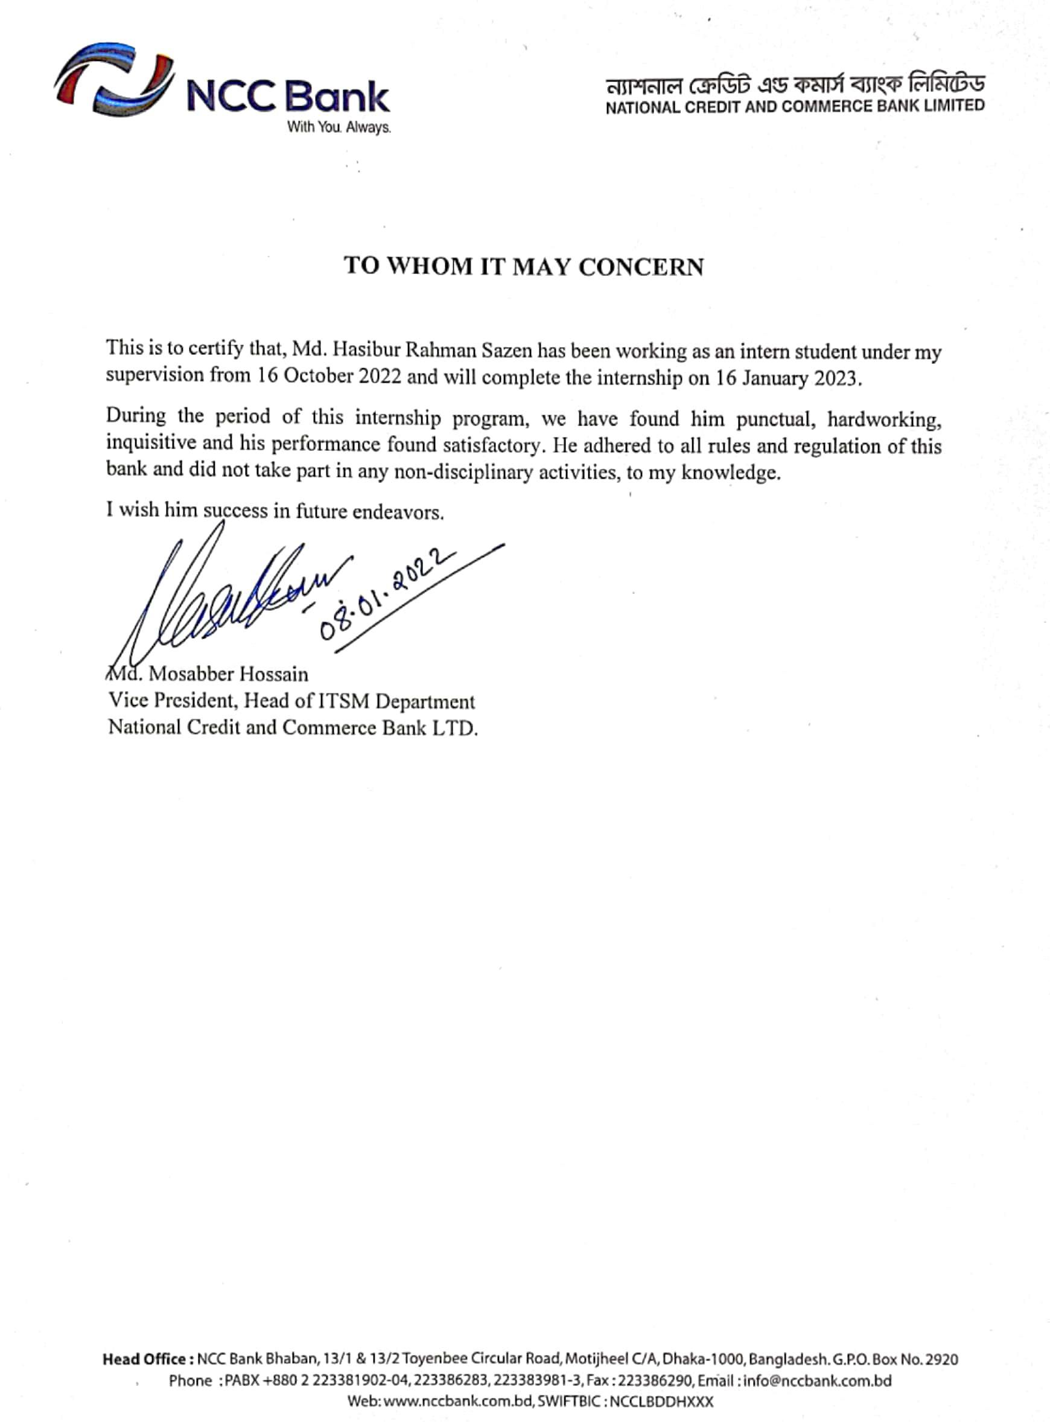

**REFERENCES**(*references of any materials used/cited in the report from different sources*)

1. <https://en.wikipedia.org/wiki/NCC_Bank>
2. <https://www.nccbank.com.bd/>
3. <https://www.wikipedia.org/>

**APPENDICES**

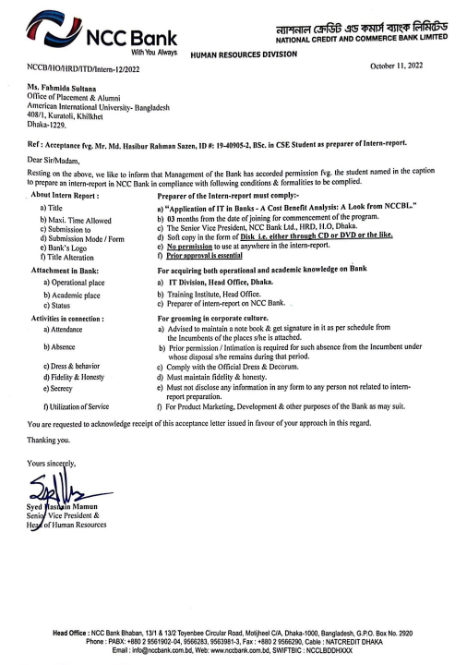

(*The following part is only to be followed in preparing the report*)

**Instructions**

* **FRONT& BACK COVER**:
  + Spiral bind.
  + Cover color is **Blue**.
* The **font** is ‘**Times new Roman**’,
* The **font size** of all the **titles** are **16 down to 12**, 16 being the main title, 14 **subtitle**, and so on.
* The **font size** of all the **text** must be **11** andall text should be **justified**.
* From the **Paragraph**🡪**Indents & Spacing tab**.
  + **Line spacing**🡪**1.5 lines**.
  + **Spacing🡪Before** and **After** both will be **6 pt**.
  + Check **√**the box ‘**Don’t add space between paragraphs of the same style**’.
* Every chapter must start at a **new page**.
* All the gaps between the paragraphs, titles, etc. should be same.
* All figures and tables must be indexed.
* The Report should not be less than **25 pages** excluding the *Appendices*.
* **3 copies** of the final Internship Report – one for yourself, one for the organization you worked in, and one for the supervisor/department.
* Make sure you have **signed** in the *Letter of Submittal* page.
* Also **get signature** from both the supervisors – university & organization on the *Letter of Endorsement* page.